1. A title indicating what application-layer protocol is being used.

2. 1-2 paragraphs explaining how that protocol works and what it is used for. Include images and diagrams as necessary. Explain the steps taken in communication of the protocol.

- Include an image of the back-and-forth communication the protocol did in the pcap to help illustrate your explanation.

3. 2-3 paragraphs explaining what happened in the communication across the network.

- You should at least answer:

- Who was sending/receiving information?

- What was the topic of conversation?

- What data was transmitted?

- Include information such as ports used, source/destination IPs, and how much data was transmitted.

- **\*\*Use images throughout to explain how you found this information.\*\***

4. Any other information of note related to the PCAP file.

Hyper Text Transfer Protocol (HTTP)

Hypertext Transfer Protocol is the foundation of any data exchange on the web. It gives the user a way to interact with data between the client and server structure. HTTP is an application layer protocol that uses the Transport Control Protocol to communicate with the server. It is used to fetch hypertext documents, post content to servers, and fetch parts of a document to update web pages on demand.

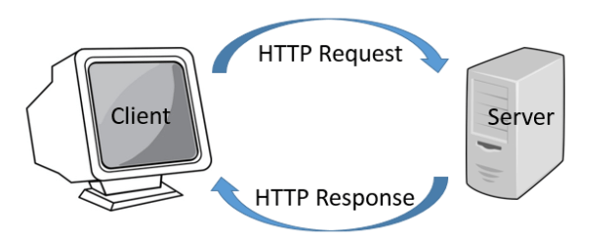

Each individual client request is sent to a server, which then provides a response. This connection is controlled at the transport layer. After a connection is made, the user-agent gives the HTTP request that navigates through the web. The browser translates these directions in HTTP requests and then interprets the response to present the user with a clear response. There was 40327 bytes of data transmitted. The source ip is 69.163.176.56 on port 80 and the destination ip is 172.16.16.128 on port 1989.

Simple Mail Transfer Protocol (SMTP)

The Simple Mail Transfer Protocol is part of the application layer. it directs the movement of email using codes that simplify the communication between email servers. Each email has the sender’s and recipient’s address.

When the email is sent, the email client connects to the SMTP server of the sender’s email service. The client transmits the address of the sender, the address of the recipient and the content of the message. The SMTP server locates the whereabouts of the recipient by using their mail address. This is when the SMTP server gives the email to SMTP server of the recipient’s email server. This server checks and confirms that the mail addressed to the recipient belongs to it.

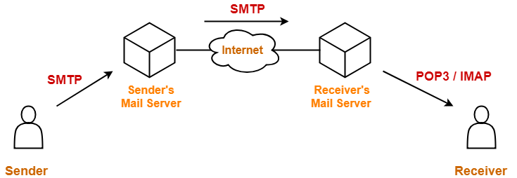

mu@musecurity was sending the information to [313337@musecutity.com](mailto:313337@musecutity.com). The source and destination ip are both 127.0.0.1. the source port being used is 7041 and the destination port is 25.

TCP and FTP

TCP - Transmission Control Protocol is the underlying communication language of the internet. TCP is responsible for taking large amounts of data, compiling it into packets and sending them on their way to be received by a fellow TCP layer, which turns the packets into useful information/data.

FTP - File Transfer Protocol a system of rules that networked computers use to communicate with one another. FTP is a client-server protocol that may be used to transfer files between computers on the internet.

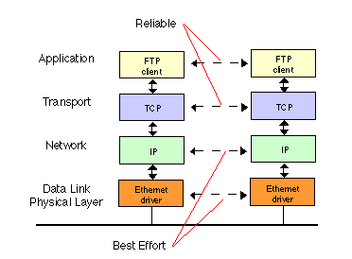

Networking communication is full of some very technical concepts based on some simple principles: Packets, Hubs, Bridges, Switch, Router, IP address, Domain name, DNS, Packet-Switching and Protocol. The sender was using 172.16.16.121 on port 21 and the receiver was on 176.16.16.128 on port 2555.